Let's **enable Playwright video recording in GitHub Actions CI for debugging.**

**Step 1: Update Playwright Config to Record Videos**

In your playwright.config.ts, add this:

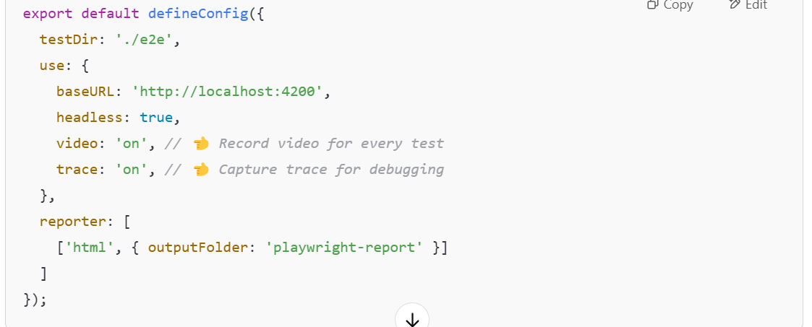

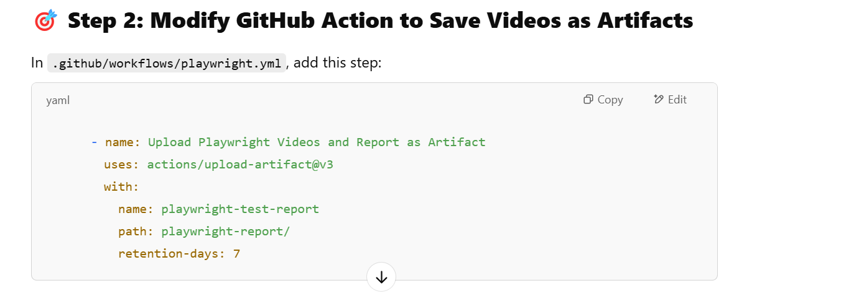

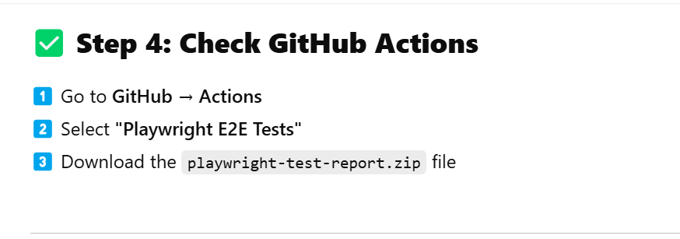**🎯 Inside the Report:**

* 📽️ **Recorded Videos for Each Test**
* 📜 **HTML Test Report**
* 🛤️ **Playwright Trace Viewer for Debugging**

**🎉 🎯 Your Angular 17 Playwright Tests Now Have Video Debugging in CI!**